**Project Design Phase-II**

**Data Flow Diagram & User Stories**

|  |  |
| --- | --- |
| Date | 13 October 2022 |
| Team ID | PNT2022TMID39291 |
| Project Name | Skill / Job Recommender |
| Maximum Marks | 4 Marks |

**Data Flow Diagrams:**

A Data Flow Diagram (DFD) is a traditional visual representation of the information flows within a system. A neat and clear DFD can depict the right amount of the system requirement graphically. It shows how data enters and leaves the system, what changes the information, and where data is stored.  **Example:** [**(Simplified)**](https://developer.ibm.com/patterns/visualize-unstructured-text/)

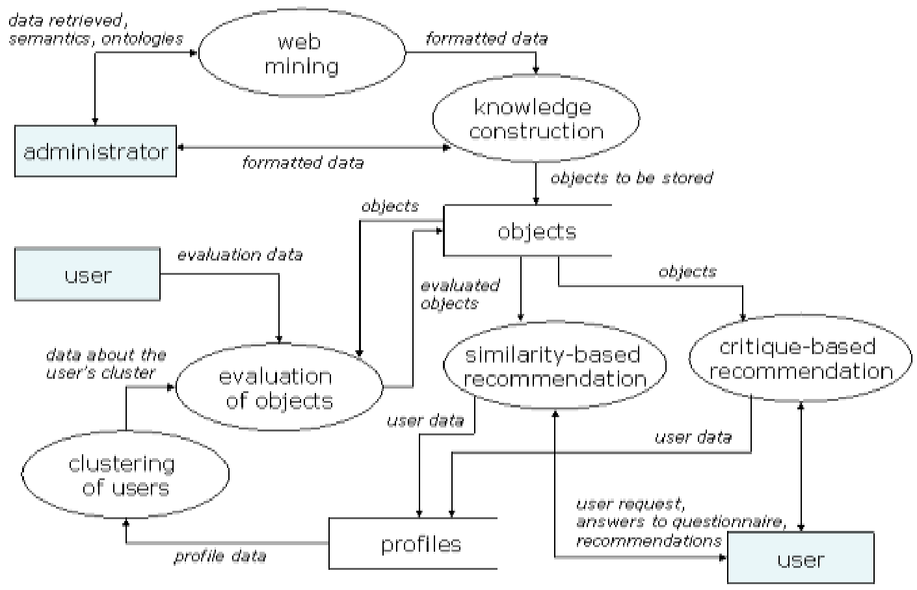

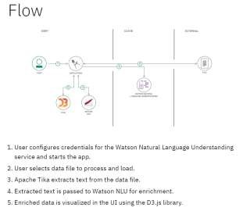

| **User Type** | **Functional Requirement (Epic)** | **User Story Number** | **User Story / Task** | **Acceptance criteria** | **Priority** | **Release** |
| --- | --- | --- | --- | --- | --- | --- |
| Job Seeker | Increase the personal skill and technical skill | USN-1 | As a job seeker I can register and this application by providing the details like my email, passwords | I can have the access control on my account and other features | High | Sprint-1 |
|  |  | USN-2 | As a user, I will receive confirmation email once I have registered for the application | I can receive confirmation email & click confirm | High | Sprint-1 |
|  |  | USN-3 | As a user, I can register for the application through Facebook | I can register & access the dashboard with Facebook Login | Low | Sprint-2 |
|  |  | USN-4 | As a user, I can register for the application through Gmail |  | Medium | Sprint-1 |
|  | Login | USN-5 | As a user, I can log into the application by  entering email & password |  | High | Sprint-1 |
|  | Dashboard |  | As a user, I can login and chat with the  chatbot |  |  |  |
| Customer (Web user) | Registration | USN-7 | As a user, I can log on and register the  application for the services being provided | I can access my account / dashboard | High | Sprint-1 |
|  |  | USN-8 | As a user, I will receive confirmation email  once I have registered for the application | I can receive confirmation  email & click confirm | High | Sprint-1 |
|  | Login | USN-9 | As a user, I can log into the application by  entering email & password | I can log on to the  application through email  id and password | High | Sprint-1 |
| Customer Care Executive | Should  Regularize the  Send grid service | USN-10 | As an executive and service operator of the  service they should make sure that service  provided are properly send and received by  the user. |  | High | Sprint-2 |
|  | Should monitor the chatbot regularly whether working or not | USN-11 | As an executive to provide a quality-based service chatbot is important for assisting if any assistance is needed for the user |  | High | Sprint-2 |